**Present Continuous**

Emprega – se este tempo verbal nas seguintes situações:

* Ações que estão acontecendo agora, neste momento, atualmente. É o que chamamos de gerúndio.

Ex: What are you doing now?

I am studying now.

* Estrutura do Present **Continuous**:

Suj+ Verb to be (AM, ARE, IS) + verbo principal com ING + complemento

Suj + verb to be + not + …..

Verb to be +suj + verbo principal com ing+ complemento

* Advérbios mais comuns nesse tipo de sentença: Now, at this moment, at present, today.
* Acrescentamos ING para a maioria dos verbos, sem afetar a ortografia.
* Quando o verbo termina em E, tiramos o E e acrescentamos o ING

Make/ making

Use/ using

Have/ having

* Quando os verbos que forem CVC, dobra – se a última consoante

Run/running

Hit/hitting

* Quando os verbos terminam em IE, tirar o IE e acrescentar o YING

Lie/lying

Die/Dying

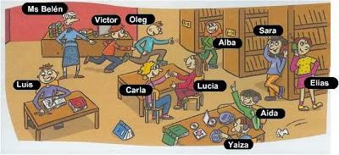

Complete o texto com os verbos:  drink, eat,  have, listen, play, rain, read, sit, talk e write (no presente contínuo).

Hi everyone. We're on holiday in Germany but the weather is bad today. It_raining. We _siting in a café at the moment. I've got my computer and I _writing my blog.

My sister _listening to music. My brothers aren't in the café. They playing football in the rain! My mum _talking_ to her friends on the phone. And my dad? He_reading_the newspaper. Oh yes, and my grandparents are here too. They_eating cakes! I haven't got a cake but I _drinking fruit juice. I like it!

We having a good time.

See you soon.